

CLOUD INFRASTRUCTURE (CSE -5240) MINI PROJECT REPORT ON

Fitness App Using Azure Data Studio

SUBMITTED TO
Department of Computer Science & Engineering

by

Pasupuleti Rohithsaidatta 230913003
Chinmaya D Kamath 230913006
2nd semester

Name & Signature of Evaluator 1 Name & Signature of Evaluator 2

(Jan 2023 – May 2023)

Table of Contents
 |  |  | Page No
Chapter 1 | INTRODUCTION |  | 3
Chapter 2 | LITERATURE REVIEW |  | 4
Chapter 3 | METHODS AND METHODOLOGY |  | 5
Chapter 4-5 | PROJECT DESIGN AND IMPLEMENTATION |  | 6-9
Chapter 6 |  | OVERVIEW OF TECHNOLOGIES USED | 10-11
Chapter 7 | RESULTS |  | 12-13
CONCLUSIONS |  |  | 14
REFERENCES |  |  | 15

- INTRODUCTION
In today's world, people are facing various health issues due to unhealthy eating habits and a lack of physical exercise. To address this issue, an AI-based diet and exercise consultant application is being developed to help individuals lead a healthy lifestyle.
The main objective of this application is to create an innovative and efficient way to achieve and maintain an individual's fittest life by providing personalized daily diet plans and physical activities. With this AI-based Diet Consultant application, individuals can have easier accessibility to a new and innovative way of maintaining a healthy lifestyle. A balanced diet is essential as it provides the necessary nutrients for the body to work effectively, reducing the risk of diseases, infections, and fatigue.
However, in today's busy day-to-day life, approaching a real-world dietician can be a challenge.
The AI-based diet and exercise consultant application eliminate the need for real-world dieticians and provide a handy and efficient diet plan and physical challenges for every day.
This research paper will investigate the effectiveness of an AI-based diet and exercise consultant application in helping individuals achieve their fitness goals and lead healthy lifestyles.

In today's fast-paced world, maintaining a healthy lifestyle has become a challenge for many. The lack of proper nutrition and physical exercise has led to an increase in health issues among people. To address this problem, an AI-based diet and exercise consultant application is being developed that can provide personalized daily diet plans and physical activities.
The main objective of this application is to help individuals achieve and maintain their fittest life by providing an efficient and handy diet plan, eliminating the need for real-world dieticians.
A balanced diet is crucial as it provides proper nutrition for the body to work effectively, reducing the risk of disease, infection, and fatigue.
Additionally, a good diet can help individuals manipulate their calorie intake based on their needs.
The AI-based diet and exercise consultant application can help individuals overcome their unhealthy eating habits and lead healthy lifestyles. This research paper will investigate the effectiveness of an AI-based diet and exercise consultant application in helping individuals achieve their fitness goals and lead healthy lifestyles.

- LITERATURE REVIEW
In recent years, the intersection of artificial intelligence (AI) and healthcare has garnered substantial attention, with a specific emphasis on diet and nutrition. AI-driven solutions have exhibited promising capabilities in delivering personalized healthcare interventions, thereby potentially enhancing health outcomes.

Personalized Diet and Exercise Plans
AI-based diet consultants have emerged as prominent tools for personalized health management. These systems leverage machine learning algorithms to formulate tailored diet and exercise regimens based on individual health parameters, such as body mass index (BMI) and basal metabolic rate (BMR). Such personalized interventions aim to assist individuals in achieving and sustaining healthier lifestyles.
Tong et al. explored the role of mobile applications and fitness trackers in promoting healthy behaviors during the COVID-19 pandemic. Their cross-sectional survey highlighted the potential of technology-driven solutions in facilitating adherence to healthful practices, including diet and exercise management [1]. Similarly, Subramanian conducted a content analysis of mobile health applications focusing on weight loss, indicating the growing interest in utilizing digital platforms for health management [2].

Effectiveness of AI-Based Interventions
Evidence suggests the effectiveness of AI-based diet and exercise consultants in promoting positive health outcomes. A study by Jimoh et al. compared diet and exercise monitoring using smartphone apps versus traditional paper diaries. The results indicated the feasibility and potential advantages of mobile applications in enhancing adherence to health regimens [3]. Furthermore, Taware et al. presented an AI-based workout assistant and fitness guide, illustrating the potential of AI-driven tools in guiding and supporting individuals towards their fitness goals [4].

Real-Time Feedback and Integration with Wearable Devices
Beyond personalized recommendations, AI-powered diet consultants offer real-time feedback and support, further enhancing user engagement and adherence. Chatbots, powered by AI algorithms, deliver instantaneous responses to user queries, fostering motivation and adherence to health plans.
Integration with wearable devices, such as fitness trackers and smartwatches, presents another avenue for AI-driven interventions. These devices capture valuable health metrics, including heart rate, steps, and sleep patterns. Leveraging this data enables the provision of even more tailored recommendations, catering to the unique needs and objectives of individuals.
In summary, AI-based diet consultants hold substantial promise in transforming the landscape of diet and nutrition management. By harnessing the capabilities of machine learning algorithms and integrating with wearable technology, these solutions offer personalized guidance, real-time support, and enhanced user engagement, thereby facilitating the pursuit and maintenance of healthier lifestyles.

- METHODS AND METHODOLOGY

Generating Diet
Method: The new user must sign up and the old user must log in in order to use the application. After registration, the user must enter his user details, such as height and weight, to calculate the BMI and BMR.
Methodology: Research and choose a reliable formula to calculate BMI and BMR, and ensure that the application includes a validation process to check the input data for accuracy.

Generating Exercises
Method: The application uses artificial intelligence algorithms to suggest exercises for the user based on their BMI and BMR.
Methodology: It chooses the machine learning algorithm that can analyze user data and generate a list of recommended exercises for the user. Ensure that the application includes a variety of exercise options to choose from.

Synchronizing Google Fit data
Method: The application uses the Google Fit API to sync and display various health metrics such as Steps, Heart Rate, Blood Pressure, Oxygen Saturation, Blood Glucose, and Body Temperature.
Methodology: Use the step data to send notifications to the user to walk more, and reminders to stay hydrated.

Active Notifications
Method: The application uses the step data to send notifications to the user to walk more, and reminders to stay hydrated, training & Motivational Videos
Methodology: Develop a notification system that can analyze the user's step data and send notifications accordingly. Ensure that the notifications are not intrusive and can be customized to suit the user's preferences.

Chatbot
Method: The application consists of a chatbot where the chatbot responds to the user's questions based on artificial intelligence by using Dialog flow essentials
Methodology: Chat bot responds to the user questions based on intents and knowledge-based data which is trained for it.

Training & Motivational Video
Method: The application uses artificial intelligence algorithms to suggest workout training and motivational videos to users.
Methodology: It uses a machine learning algorithm that can analyse user data and generate a list of recommended workout training and motivational videos. Ensure that the videos are high-quality and are tailored to the user's preferences and fitness level.

- Project Implementation
The Project application is loaded in Android Studio. We used Android Studio for the Design and coding of the project.

HARDWARE REQUIREMENT
Device: Laptop or PC
Operating System: Windows 7 or higher
Processor: Intel i3 or equivalent, or higher
RAM: 8 GB or more
Storage: 100 GB or more

ANDROID PHONE
6.0 or above

SOFTWARE REQUIREMENT
LAPTOP OR PC
Android Studio
Azure Data Studio

PROJECT DESIGN
- System Architecture

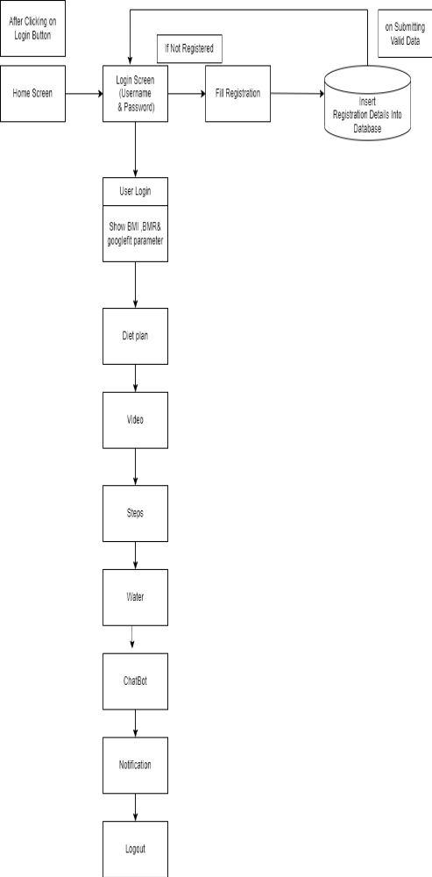
Fig 1 System Architecture

- Activity Diagram
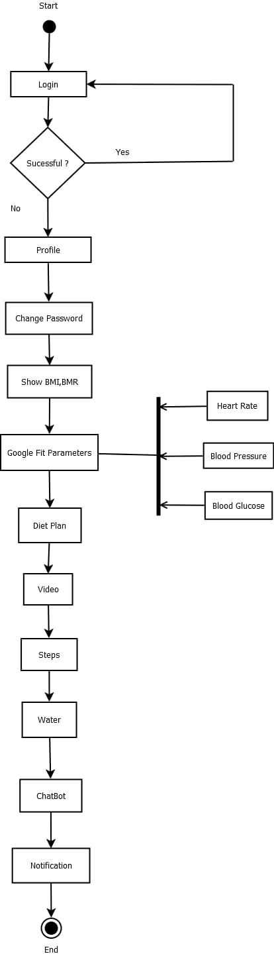
Fig 2 Activity Diagram
- Sequence Diagram
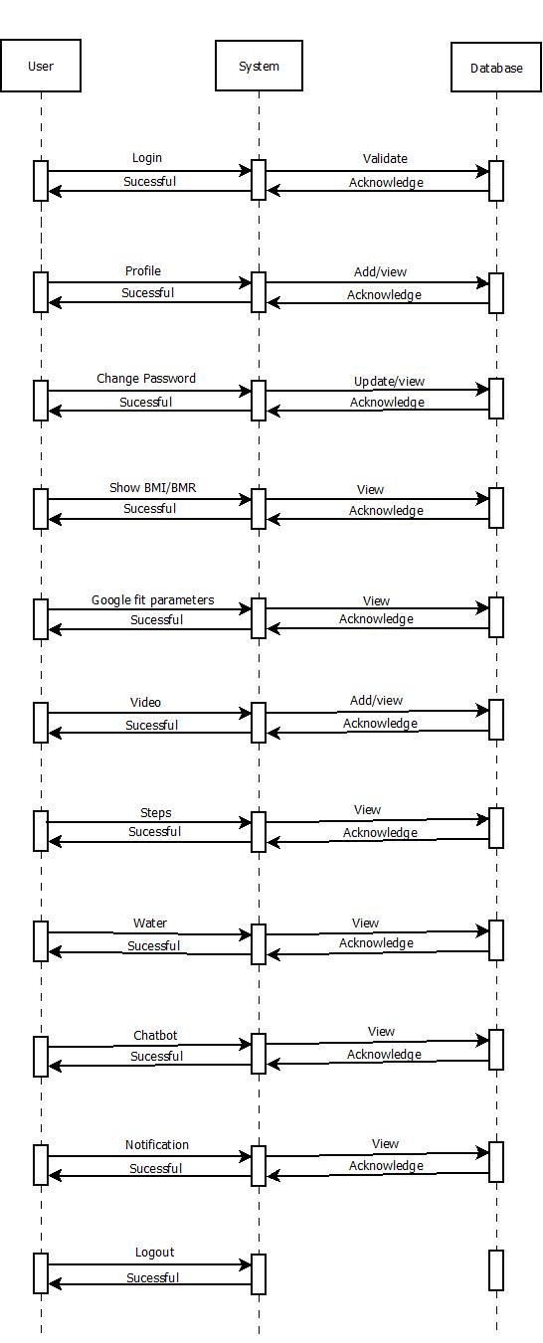
Fig 3 Sequence Diagram

- OVERVIEW OF TECHNOLOGIES USED

- Android studio
Android Studio is the official IDE for developing Android apps, based on IntelliJ IDEA. It offers a flexible Gradle-based build system, a fast emulator, and a unified environment for developing for all Android devices. With features like Instant Run, code templates, and GitHub integration, developers can build apps quickly and efficiently. Android Studio also includes testing tools and frameworks, Lint tools to catch issues, C++ and NDK support, and built-in support for Google Cloud Platform, making it easy to integrate Google Cloud Messaging and App Engine into your app.

- XML
XML is a markup language used for designing the user interface of Android applications. It allows developers to create a visual representation of the app's layout, including views such as buttons, text fields, images, and more. XML is used to define the structure, layout, and behavior of UI elements in an Android app. It's also used to specify resources such as colors, strings, and dimensions, which can be reused throughout the app. Android Studio provides a visual editor for XML layouts, making it easy to create and modify UI elements.

- JAVA
Java is one of the primary programming languages used for developing Android applications. It is an object-oriented language with a rich set of libraries and frameworks that make it easier to develop complex applications. Java is a popular choice for Android development because it is platform-independent and has a large developer community with extensive documentation and resources.

Project Structure
Android Studio organizes projects into modules containing source code and resource files, such as Android app modules, library modules, and Google App Engine modules. All build files are visible at the top level under Gradle Scripts, and app modules contain the Manifests, Java, and Res folders for organizing code and resources. The view of project files can be customized to focus on specific aspects of app development, including displaying recognized coding and syntax errors in the Problems view.

- The User Interface
The Android Studio user interface consists of a toolbar, navigation bar, editor window, tool window bar, and status bar. The toolbar allows users to perform actions such as running an app or launching Android tools. The navigation bar provides a compact view of the project structure, and the editor window is where code is created and modified. Tool windows provide access to specific tasks, such as project management or version control, and can be expanded or collapsed. The status bar displays project and IDE status, as well as warnings and messages. Users can customize the main window by hiding or moving toolbars and tool windows and can access IDE features through keyboard shortcuts. The search function allows users to locate specific actions or elements within the IDE.

- The Tool Window
Android Studio has various tool windows, which are automatically displayed based on the context. You can expand, collapse, drag, pin, unpin, attach, detach, and customize these tool windows to suit your needs. You can also restore the default layout or store the current layout as default. To show or hide the tool window bar, click the window icon in the bottom left-hand corner. To locate a specific tool window, hover over the window icon and select the tool window from the menu.

- Gradle Build System
Android Studio uses the Gradle build system to customize, configure, and extend the build process. You can create multiple APKs, reuse code and resources, and more. The build files are named build Gradle and use Groovy syntax. Android Studio generates the necessary build files when you import a project.

- Multiple APK Support
Multiple APK support lets you create different APKs based on screen density or ABI, making it easier to target specific devices. This allows for greater efficiency in development and allows APKs to share certain settings.

- Code Inspections
Android Studio's code inspections help identify and correct problems with your code's structural quality. The Lint tool checks for bugs and optimization improvements, covering correctness, security, performance, usability, accessibility, and internationalization.

- Debug And Profile Tools
Android Studio has built-in tools for debugging and performance analysis to help you improve your code.

- Azure Data Studio
Azure Data Studio is a cross-platform database tool that can be used in conjunction with Android Studio for managing and querying databases. It provides a modern, intuitive interface for performing tasks such as creating databases and tables, executing queries, and analyzing query performance. With Azure Data Studio, you can connect to a wide range of database platforms, including SQL Server, PostgreSQL, and MySQL, among others. The tool also supports extensions, enabling you to add additional functionality to meet your specific needs.

- Dialogue flow
Dialogue flow is a natural language processing (NLP) platform that enables developers to design and integrate conversational user interfaces into mobile apps, web applications, devices, and bots. It uses machine learning algorithms to understand and respond to user requests in a conversational manner. With Dialog flow, developers can create chatbots, voice assistants, and other conversational interfaces that can be integrated into Android Studio projects.

Results
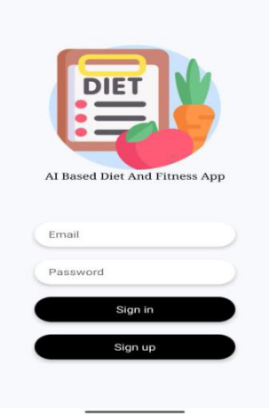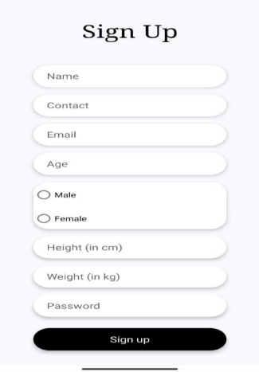
Fig 1 Application User Interface and Sign up.

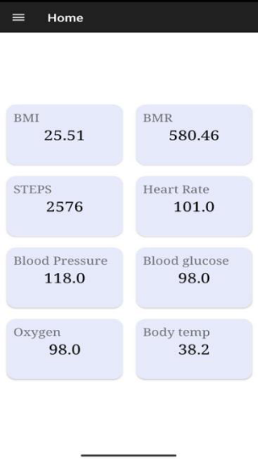
Fig 2 Google Fit Parameters

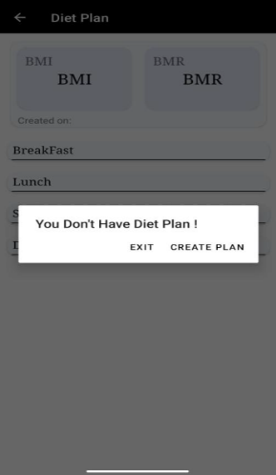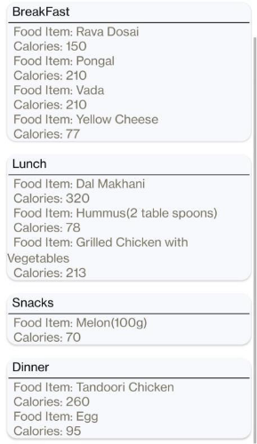
Fig 3 Creating Diet Plan to the user based on BMI
and BMR.

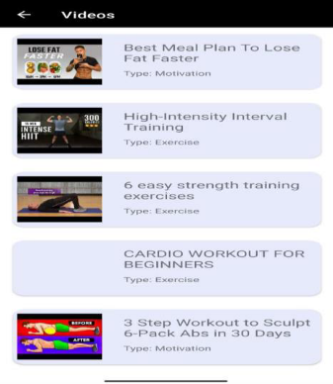
Fig 4 Suggesting Fitness videos to the user based on BMI & BMR.

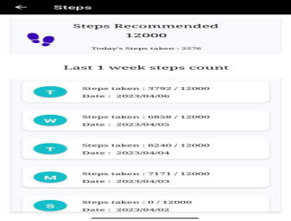
Fig 5 Recommends steps and water Intake to the user.

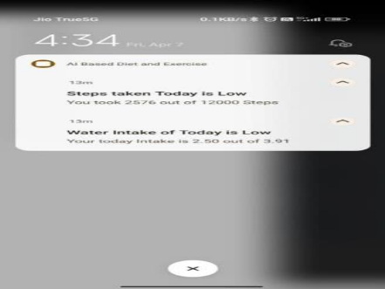
Fig 6 Notify the users through Notifications About Steps taken and Water Intake taken at that day.

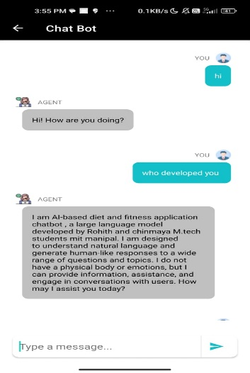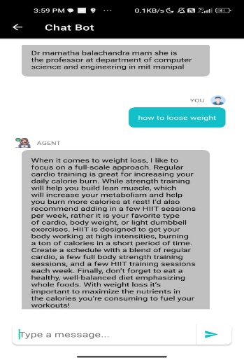
Fig 7 Chat Bot responding to the users input.

- Benefits of this Application

- Load Balancing:
Benefit: By limiting the amount of load on the server during admin access, the system can operate more efficiently and handle the workload more effectively.

- Easy Accessibility:
Benefit: This feature allows for easy storage and access to records and information, which can save time and improve productivity. Users can quickly retrieve the information they need without having to spend a lot of time searching for it.

- User-Friendly:
Benefit: A user-friendly website or application can increase user engagement and satisfaction, leading to more positive experiences with the system. This can result in increased usage and better adoption rates.

- Efficient and Reliable:
Benefit: Maintaining a secure database on a server can be more efficient and reliable than storing data on spreadsheets or physical record books. This can save time and reduce errors, while also improving data security.

- Easy Maintenance:
Benefit: A system that is easy to maintain can save time and money on maintenance costs. This can free up resources to focus on more critical tasks, such as improving the system's functionality and adding new features.

Conclusion
In conclusion, AI-powered diet consultants hold significant promise in revolutionizing the landscape of diet and nutrition management. By harnessing the capabilities of machine learning algorithms and integrating with wearable technology, these solutions offer personalized guidance, real-time support, and enhanced user engagement, facilitating the pursuit and maintenance of healthier lifestyles.

Our project focused on the development of a Fitness Application using Azure Data Studio, implemented in the Java programming language. The creation of this system required substantial effort and commitment from our team. While achieving perfection in the ever-evolving field of software development is challenging, we recognize the potential for further refinements in this application.

Through this project, we have gained valuable insights and expanded our knowledge in the realm of software development. We are confident that these experiences will serve as a valuable steppingstone for our future projects and endeavors in this exciting field.

References
- H. L. Tong, C. Maher, K. Parker, T. D. Pham, A. L. Neves, B. Riordan, C. K. Chow, L. Laranjo, and J. C. Quiroz, "The use of mobile apps and fitness trackers to promote healthy behaviors during COVID-19: A cross-sectional survey," PLOS Digital Health, Published: August 18, 2022. [Online]. Available: https://doi.org/10.1371/journal.pdig.0000087

- R. Subramanian, "DIET, EXERCISE, AND SMARTPHONES - A CONTENT ANALYSIS OF MOBILE HEALTH APPLICATIONS FOR WEIGHT LOSS," Southern Illinois University Carbondale, OpenSIUC, 2015. [Online].

- F. Jimoh, E. K. Lund, L. J. Harvey, C. Frost, W. J. Lay, M. A. Roe, R. Berry, and P. M. Finglas, "Comparing Diet and Exercise Monitoring Using Smartphone App and Paper Diary: A Two-Phase Intervention Study," Monitoring Editor: G. Eysenbach, Florence Jimoh et al., Food Angels UK Ltd, Newmarket, United Kingdom; Independent Consultant, Norwich, United Kingdom; Quadram Institute Bioscience, Norwich Research Park, Norwich, NR4 7UA, United Kingdom, 2022.

- G. Taware, R. Agrawal, P. Dhende, P. Jondhalekar, and S. Hule, "AI-based Workout Assistant and Fitness guide," International Journal of Engineering Research & Technology (IJERT), vol. 10, no. 11, pp. 154-160, November 2021. [Online]. Available: https://doi.org/10.17577/IJERTV10IS110154

